ORTHOPAEDIC INSTRUMENTS
Ilizarov External Fixator System
5.8 Ring
Intended Use
The Ilizarov 5.8 ring is a full circular fixator ring used as the primary structural element of Ilizarov circular external fixator frames in veterinary orthopaedic surgery. It is used for fracture fixation, limb lengthening, angular deformity correction and bone transport in dogs, cats and equines undergoing distraction osteogenesis. | 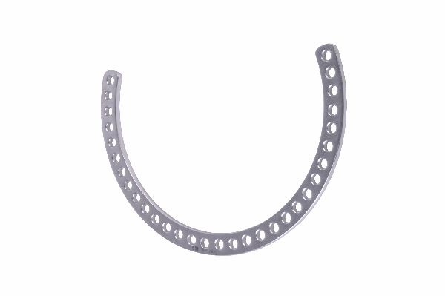
Function
The ring is manufactured from stainless steel or aluminium alloy and features multiple uniformly spaced holes around its circumference. These holes accept tension wires, olive wires, threaded rods, connecting bolts and accessory components. Multiple rings are stacked along the limb axis and interconnected by threaded rods to form the complete Ilizarov frame construct.
Advantages
Full Circumferential Wire Fixation: The complete ring geometry allows tension wires to be anchored diametrically across the bone, distributing fixation forces symmetrically around the bone circumference and providing superior angular stability compared with half-pin unilateral fixators.
Modular Multi-Hole Construction: The regularly spaced hole array accommodates wires, pins and rods at virtually any circumferential position, enabling the frame to be tailored to each patient's unique anatomy without modifying the ring.
FAQ
Q: What ring sizes are available in the Ilizarov system?
A: Veterinary Ilizarov rings are available in diameters from 60 mm to 160 mm in 10–20 mm increments, with the ring chosen to maintain a 1–2 cm clearance from the limb surface for skin hygiene.
Q: Can full rings and half rings be combined in the same Ilizarov frame?
A: Yes. Full rings, half rings and arched supports are routinely combined in the same frame to accommodate joint proximity, muscle bulk and planned osteotomy levels.

ORTHOPAEDIC INSTRUMENTS
Ilizarov External Fixator System
Bushing
Intended Use
Ilizarov bushings are small cylindrical spacer components used in veterinary Ilizarov circular external fixator constructs to fill unused wire holes on rings, provide offset wire attachment points and interface between ring holes and specialised connecting components during limb reconstruction in dogs and cats. | 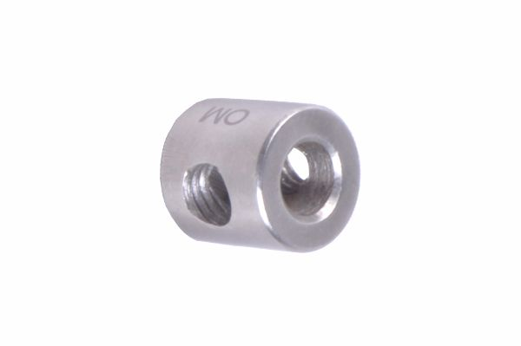
Function
The bushing is a precision-machined stainless steel cylinder sized to press or thread into a ring hole. It provides a flat bearing surface for wire bolt heads, accommodates wires at offset positions away from the ring plane and prevents crushing of the ring hole walls when tightening wire fixation bolts at high tension levels required for stable distraction osteogenesis.
Advantages
Prevents Ring Hole Damage Under Wire Tension: The bushing distributes the compressive load of wire fixation bolt tightening over a larger ring contact area, preventing hole elongation and ring deformation that would reduce wire fixation security over the distraction period.
Enables Offset Wire Positioning: Offset bushings extend the wire attachment point laterally from the ring face, allowing the wire to pass closer to the bone in patients where the standard ring-to-bone clearance is insufficient.
FAQ
Q: Are bushings required in every Ilizarov ring hole?
A: No. Bushings are used selectively in holes where wires are attached, where offset positioning is needed, or where repeated wire changes risk damaging the ring hole thread.
Q: What material are veterinary Ilizarov bushings made from?
A: Bushings are typically manufactured from grade 316L surgical stainless steel, matching the ring material to prevent galvanic corrosion at the ring interface.

ORTHOPAEDIC INSTRUMENTS
Ilizarov External Fixator System
Connection Bolt
Intended Use
Ilizarov connection bolts are the primary fasteners used to assemble rings, threaded rods, plates and accessory components in Ilizarov circular external fixator frames for veterinary fracture fixation and limb reconstruction in dogs and cats. They provide the rigid inter-component connections that maintain frame geometry during distraction osteogenesis. | 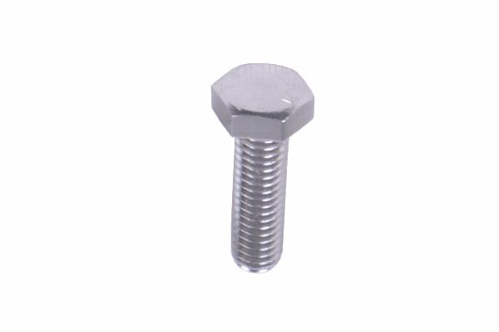
Function
Each bolt passes through aligned holes in adjacent ring or plate components and is secured by a matching nut. The bolt head is sized to sit within the ring hole countersink, preventing rotation during tightening. Standard thread pitch ensures bolts and nuts throughout the Ilizarov system are fully interchangeable, simplifying intraoperative assembly and postoperative adjustments.
Advantages
Universal System Interchangeability: Standardised thread forms ensure connection bolts are interchangeable with all nuts, rings, threaded rods and plates in the Ilizarov system, eliminating incompatibility issues during intraoperative frame assembly and postoperative modifications.
Countersunk Head Prevents Frame Rotation: The countersunk bolt head seats firmly within the ring hole, resisting rotation during nut tightening and ensuring the full tightening torque translates to clamping force rather than being wasted in interface slippage.
FAQ
Q: What torque should be applied to Ilizarov connection bolts?
A: Connection bolts are typically tightened to 4–6 Nm using a dedicated Ilizarov wrench, sufficient to maintain frame rigidity under weight-bearing loads without risking thread stripping.
Q: Do Ilizarov connection bolts require periodic re-tightening?
A: Yes. Bolts should be checked and retightened at the first postoperative recheck (7–10 days) as biological and mechanical settling of the construct may allow minor loosening.

ORTHOPAEDIC INSTRUMENTS
Ilizarov External Fixator System
Connection Nut
Intended Use
Ilizarov connection nuts are the primary threaded fasteners used to secure connection bolts and threaded rods within Ilizarov circular external fixator frames in veterinary orthopaedic surgery. They maintain the rigid inter-ring and inter-component connections essential for stable fracture fixation and distraction osteogenesis in dogs and cats. | 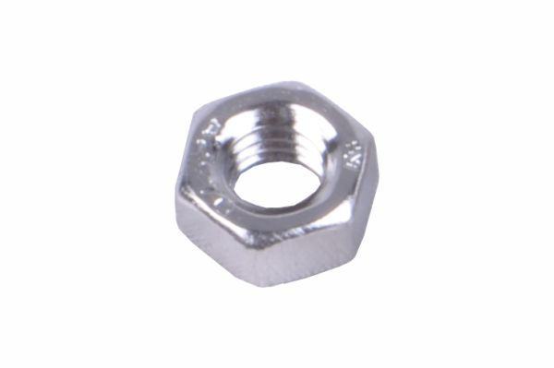
Function
The nut is threaded onto the connection bolt or threaded rod passing through the ring or plate hole. Tightening the nut against the ring or component surface clamps the assembly rigidly. The standard M6 or M8 thread pitch matches all Ilizarov system bolts and rods. Anti-loosening features may include nylon locking inserts or mechanical serrations to resist vibration-induced loosening.
Advantages
Anti-Vibration Locking Feature: Nylon-insert or mechanically serrated locking nuts resist vibrational loosening during patient ambulation, maintaining frame rigidity throughout the 6–12 week distraction and consolidation phases of Ilizarov treatment in active canine patients.
Standardised Thread Compatibility: Universal thread pitch across all Ilizarov nuts ensures complete interchangeability with all system bolts and rods, allowing intraoperative frame modifications without compatibility concerns during complex limb reconstruction procedures.
FAQ
Q: Should Ilizarov connection nuts be single-use or reusable?
A: Stainless steel nuts without nylon inserts are autoclavable and reusable; nylon-insert locking nuts should be replaced after each use as the nylon deforms on first tightening and does not provide reliable locking on reuse.
Q: What wrench size is required for Ilizarov connection nuts?
A: Standard Ilizarov system nuts require an 11 mm or 13 mm open-ended or ring spanner, available in the Ilizarov wrenches (spanner) instrument set.

ORTHOPAEDIC INSTRUMENTS
Ilizarov External Fixator System
Connection Plates
Intended Use
Ilizarov connection plates are flat bridge components used in veterinary Ilizarov external fixator constructs to span gaps between non-aligned ring holes, connect adjacent rings at close inter-ring distances and attach accessory components to the main frame during fracture fixation and limb reconstruction in dogs and cats. | 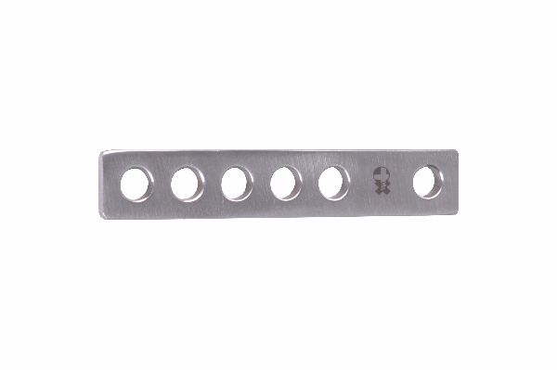
Function
Each plate is a flat stainless steel bar with multiple holes at standard Ilizarov spacing. Plates are positioned across adjacent ring faces and secured using connection bolts, forming a rigid bridge. The multiple hole positions accommodate varied ring-to-ring spacings and allow accessory items such as motor units, telescopic rods and half rings to be attached at custom positions.
Advantages
Bridges Non-Aligned Ring Holes: Connection plates allow components to be attached between ring holes that do not directly align, dramatically increasing frame assembly flexibility during complex multi-ring constructs for angular deformity correction.
Short Inter-Ring Distance Accommodation: When rings must be placed very close together near joint lines or osteotomy sites, connection plates span the gap without requiring a threaded rod, maintaining frame rigidity at tight inter-ring spacings.
FAQ
Q: When are connection plates preferred over threaded rods in Ilizarov frames?
A: Connection plates are used when the inter-ring distance is less than 20–30 mm (too short for a threaded rod) or when a rigid rather than adjustable inter-ring connection is required at a specific frame level.
Q: Are connection plates available in different lengths?
A: Yes. Ilizarov connection plates are available in multiple lengths with varying hole numbers (typically 2–5 holes) to accommodate different ring spacings and attachment requirements.

ORTHOPAEDIC INSTRUMENTS
Ilizarov External Fixator System
Dynamometric Tensioner
Intended Use
The Ilizarov dynamometric tensioner is a calibrated wire-tensioning instrument used to apply a precise and measurable tension to Kirschner wires and olive wires during Ilizarov circular external fixator assembly in veterinary orthopaedic surgery. Correct wire tension is critical for frame stiffness and effective bone distraction in dogs and cats. | 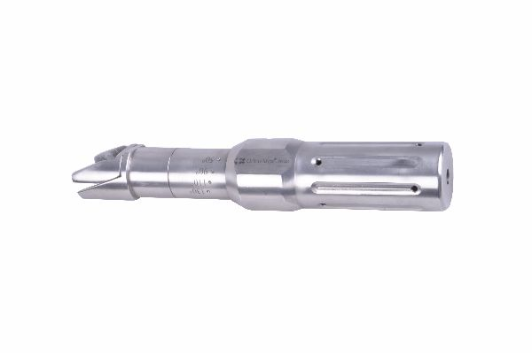
Function
The tensioner clamps onto the free end of the wire beyond the ring and incorporates a calibrated force gauge. Rotating the tensioning wheel draws the wire through the tensioner body, applying increasing tension. The integrated gauge displays the tension in kilograms-force (kgf), allowing the surgeon to achieve the standard 90–130 kgf tension required for adequate frame stiffness in Ilizarov constructs.
Advantages
Calibrated Tension Measurement: The integrated force gauge ensures each wire is tensioned to the prescribed protocol value rather than relying on subjective feel, eliminating inter-wire tension variability that would compromise frame stiffness and bone distraction quality.
One-Handed Operation During Wire Fixation: The clamp-and-ratchet mechanism holds the wire under tension while the surgeon simultaneously tightens the wire fixation bolt, preventing tension loss between tensioning and final bolt tightening.
FAQ
Q: What wire tension is standard for Ilizarov frames in dogs?
A: The recommended tension for 1.5–1.8 mm Kirschner wires in small to medium dogs is 70–100 kgf; large dogs require 100–130 kgf to achieve adequate frame stiffness under weight-bearing loads.
Q: Can the dynamometric tensioner be used for olive wires?
A: Yes. Olive wires are tensioned using the same instrument, with the olive bead seated against the ring face after tensioning to provide the transverse bone-stabilising force characteristic of olive wire constructs.

ORTHOPAEDIC INSTRUMENTS
Ilizarov External Fixator System
Extension Post - Male/Female
Intended Use
Ilizarov extension posts (male and female) are vertical spacer components used in veterinary Ilizarov circular fixator constructs to increase the distance between rings, attach accessory components above or below the main ring plane and construct multi-level frames for complex limb lengthening and deformity correction in dogs and cats. | 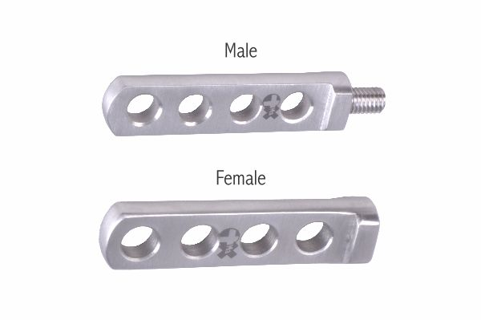
Function
Male posts have a threaded stud at one end and a ring-hole connection at the other; female posts have a threaded socket accepting the male stud. Connecting male to female posts in series increases the inter-ring separation by a fixed increment. Posts also serve as attachment points for half-arches, motor units and distraction hinges at positions above or below the primary ring level.
Advantages
Modular Height Extension: Stacking male and female extension posts provides precise, repeatable inter-ring height increments, enabling the surgeon to construct frames with custom ring separations tailored to the patient's bone length and the planned distraction gap.
Secure Male-Female Threaded Connection: The threaded post interface provides a rigid axial connection that transmits both compressive and tensile loads between frame levels, maintaining frame geometry during the alternating distraction and consolidation forces of Ilizarov bone transport.
FAQ
Q: How do extension posts differ from threaded rods in an Ilizarov frame?
A: Extension posts provide fixed, non-adjustable height increments and are used for structural frame extension; threaded rods provide adjustable inter-ring distances for active distraction or compression.
Q: What increments are extension posts available in?
A: Ilizarov extension posts are typically available in 15 mm, 30 mm and 60 mm standard lengths, which can be combined to achieve the required inter-ring spacing in any frame configuration.

ORTHOPAEDIC INSTRUMENTS
Ilizarov External Fixator System
Half Ring
Intended Use
The Ilizarov half ring is a semicircular frame component used in veterinary circular external fixator constructs near joint lines, muscle bellies and regions where a full ring cannot be placed without impinging on soft tissue. It is essential for periarticular fracture fixation and epiphyseal level wire placement in dogs and cats. | 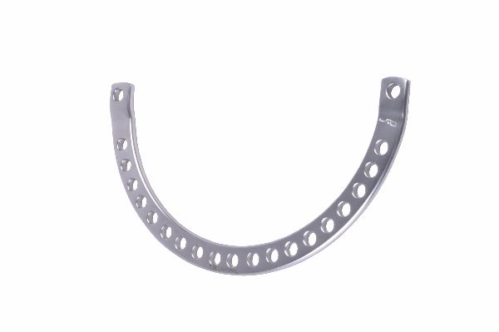
Function
The half ring spans 180° and features the same uniformly spaced hole array as full rings on its outer arc. The flat ends incorporate connection bolt holes for attaching the half ring to full rings or other frame components. Multiple half rings can be combined to approximate full ring coverage where anatomy prevents use of a complete circular ring.
Advantages
Periarticular Placement Without Joint Impingement: The semicircular profile allows the half ring to be positioned at the joint level where the limb anatomy prevents a full ring from encircling the limb without contacting skin over bony prominences or restricting joint flexion.
Combinable with Full Rings for Custom Geometry: Half rings can be connected to full rings, to other half rings and to arched supports to create custom ring configurations that exactly match the patient's limb anatomy and planned wire placement positions.
FAQ
Q: Can two half rings be used to replace a full ring?
A: Yes. Two half rings of the same diameter can be connected end-to-end using connection bolts to form a full circular ring equivalent, useful when the patient's limb must be encircled after wound dressing prevents full ring placement.
Q: What sizes do veterinary Ilizarov half rings come in?
A: Half rings match the diameter range of full rings (60–160 mm) and are selected to maintain the same 1–2 cm clearance from the limb surface as full rings in the same frame construct.

ORTHOPAEDIC INSTRUMENTS
Ilizarov External Fixator System
Hinges - Male/Female
Intended Use
Ilizarov hinges (male and female pairs) are articulating connecting components used in veterinary Ilizarov fixator constructs to create a controlled rotational axis between adjacent frame rings. They are used for angular deformity correction, joint contracture release and controlled osteotomy angulation in limb reconstruction procedures in dogs and cats. | 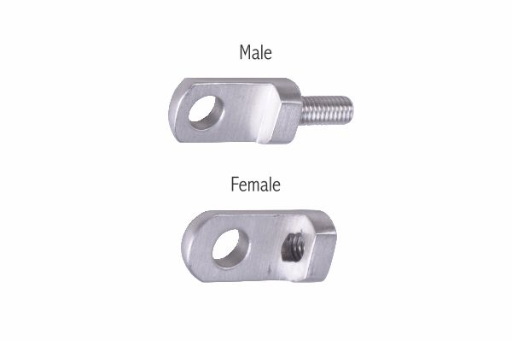
Function
The male hinge post inserts into the female hinge socket, forming a single-axis pivot. Positioned on opposite sides of the frame, a pair of hinges defines the rotational axis around which one ring segment rotates relative to another. Motor units, threaded rods or distraction devices attached to the opposite side of the ring pair drive the angular correction while the hinge pair constrains movement to the desired plane.
Advantages
Controlled Single-Axis Angular Correction: The male-female hinge pair precisely defines the rotational axis of angular correction, ensuring deformity correction occurs in the intended plane without translational or rotational aberrance that would compromise limb alignment.
Gradual Osteotomy Angulation Without Frame Disassembly: Hinged Ilizarov frames allow progressive angular correction by incremental rod adjustment over days to weeks, avoiding the need for repeated anaesthesia for manual fracture reduction and re-casting.
FAQ
Q: How many hinge pairs are needed for a single-plane angular correction?
A: One pair of hinges (one male, one female) positioned diametrically opposite on the ring pair defines the correction axis. A second pair may be added for additional stability in large or very active patients.
Q: Can Ilizarov hinges be used for joint distraction?
A: Yes. Hinged frames spanning a joint can provide gradual joint distraction with simultaneous angular correction for management of joint contracture, osteochondral defects and periarticular deformities.

ORTHOPAEDIC INSTRUMENTS
Ilizarov External Fixator System
Mono Screw - Schanz Pin Clamp
Intended Use
The Ilizarov mono screw Schanz pin clamp is a hybrid fixation component that connects a half-pin (Schanz screw) to an Ilizarov ring, enabling half-pin fixation within a circular external fixator frame. It is used in veterinary orthopaedics for hybrid ESF constructs that combine tensioned wire and half-pin fixation in dogs and cats. | 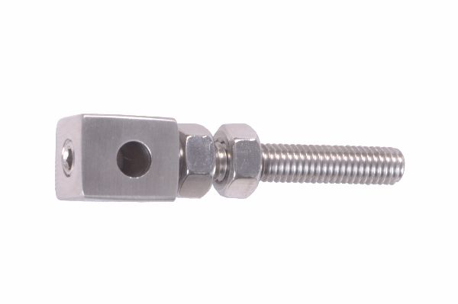
Function
The clamp body attaches to the Ilizarov ring via a standard connection bolt. A perpendicular Schanz screw channel passes through the clamp and is secured by a locking nut. The angular relationship between the channel and the ring face can be adjusted within a limited arc before final locking, allowing the Schanz screw to diverge from the perpendicular wire plane.
Advantages
Hybrid Wire and Half-Pin Fixation: Combining tensioned wires and Schanz screws in a single ring level increases the number of bone-fixation points and frame stiffness — particularly valuable near joint lines where wire passage is anatomically restricted and half pins provide better metaphyseal fixation.
Adjustable Pin Angle Within Ring Plane: Limited angular adjustment of the Schanz screw channel allows the pin to be angled away from perpendicular to avoid cortical vessels, growth plates and previous implant sites while maintaining connection to the ring structure.
FAQ
Q: What Schanz screw diameters are compatible with the mono screw clamp?
A: Ilizarov mono screw clamps typically accept 3.0–5.0 mm Schanz screws, covering the pin sizes used for metaphyseal and diaphyseal fixation in dogs ranging from toy breeds to large breeds.
Q: When is a mono screw clamp preferred over a tensioned wire in Ilizarov surgery?
A: Half pins via mono screw clamps are preferred near joints, in thick muscle compartments where wire passage is hazardous, and in areas where the bone is too wide for wire tensioning to provide adequate fixation.

ORTHOPAEDIC INSTRUMENTS
Ilizarov External Fixator System
Oblique Support
Intended Use
Ilizarov oblique supports are angled connecting rods used in veterinary Ilizarov circular fixator constructs to provide diagonal bracing between rings at different levels. They increase frame torsional stiffness and resist angular instability in complex multi-ring frames used for limb lengthening and deformity correction in dogs and cats. | 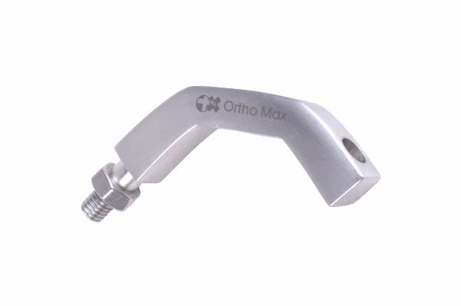
Function
The oblique support connects two ring holes at different circumferential positions and different ring levels, creating a diagonal strut within the frame. The angular orientation of the strut relative to the frame axis generates a component of resistance to both axial and torsional loads. Connection bolt holes at each end mate with standard Ilizarov ring holes.
Advantages
Improved Frame Torsional Stiffness: Diagonal oblique supports substantially increase the resistance of multi-ring Ilizarov frames to torsional loads, reducing the rotational micromotion at the bone-wire interface that can lead to wire loosening and tract infection during prolonged distraction.
Versatile Angular Positioning: Oblique supports can be positioned at various diagonal angles within the ring array, allowing the surgeon to selectively reinforce the frame in planes where the clinical load analysis predicts the greatest instability.
FAQ
Q: When are oblique supports added to a standard Ilizarov frame?
A: Oblique supports are added when frame stiffness assessment reveals excessive torsional or angular deflection under weight-bearing, typically in very active large dogs or in frames spanning long distraction gaps.
Q: Do oblique supports interfere with the distraction mechanism?
A: Oblique supports are positioned to brace ring levels that are not actively being distracted; they should not be placed between the rings containing the active distraction mechanism.

ORTHOPAEDIC INSTRUMENTS
Ilizarov External Fixator System
Olive Wire
Intended Use
Ilizarov olive wires are Kirschner wires with a small spherical bead (olive) welded at a fixed point along the shaft. They are used in veterinary Ilizarov circular external fixator constructs to apply transverse translational force to bone segments during fracture reduction and deformity correction in dogs and cats. | 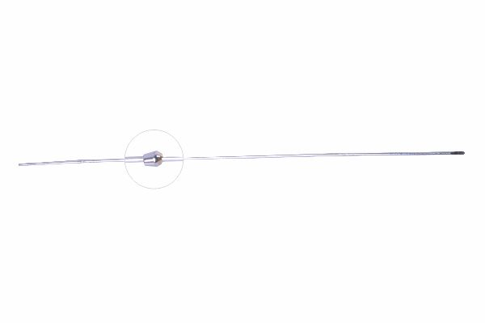
Function
The olive bead is larger than the wire hole drilled through the bone cortex. After passing the wire through the bone, tensioning is applied from the non-olive end. The olive bead, unable to pass through the cortical hole, bears against the near cortex and exerts a transverse translational force on the bone segment in the direction of tensioning. Paired opposing olive wires neutralise each other or correct translation.
Advantages
Transverse Bone Correction Without Additional Implants: The olive bead generates a translational corrective force using the same wire that provides axial fixation, eliminating the need for additional reduction clamps or implants during deformity correction in the Ilizarov frame.
Graduated Correction by Wire Tensioning: Increasing or decreasing olive wire tension postoperatively enables gradual translational correction of bone displacement, allowing the surgeon to fine-tune limb alignment during the consolidation phase without frame disassembly.
FAQ
Q: What diameter olive wires are used in veterinary Ilizarov surgery?
A: Olive wires are most commonly used in 1.5 mm and 1.8 mm diameters, matching standard Ilizarov wire sizes, with the olive bead diameter approximately 3× the wire shaft diameter.
Q: How does an olive wire differ from a standard Kirschner wire in an Ilizarov frame?
A: Standard smooth wires provide tensioned axial fixation only; olive wires additionally apply a directional transverse force to the bone via the bead, making them the primary tool for translational deformity correction.

ORTHOPAEDIC INSTRUMENTS
Ilizarov External Fixator System
Spiral (Twisted) Plates
Intended Use
Ilizarov spiral (twisted) plates are torsionally pre-curved connecting plates used in veterinary Ilizarov circular external fixator constructs to brace and stabilise rings against rotational displacement. They are used to increase frame resistance to axial rotation in limb lengthening, deformity correction and complex fracture fixation in dogs and cats. | 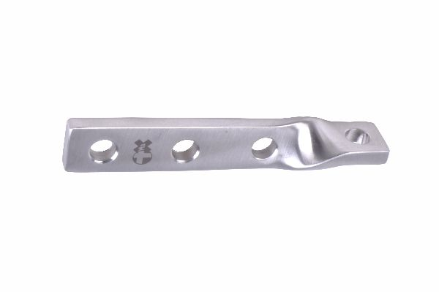
Function
Each plate is manufactured with a pre-set spiral twist along its length. When connected between two ring levels, the plate's inherent torsional geometry resists relative ring rotation about the limb axis. Connection bolt holes at each end mate with standard ring holes. The spiral pre-set is designed to be taken up under physiological rotational loads without yielding, providing elastic anti-rotation support.
Advantages
Passive Anti-Rotation Stiffness: The pre-set spiral geometry provides passive resistance to axial limb rotation without requiring active locking mechanisms, maintaining rotational frame stability during canine ambulation without imposing excessive rigidity that would prevent axial dynamisation.
Compatible with Simultaneous Distraction: Spiral plates can be applied between rings that are also being actively distracted via threaded rods, providing rotational stability without impeding the linear distraction motion essential for bone transport osteogenesis.
FAQ
Q: How do spiral plates differ from standard connection plates in an Ilizarov frame?
A: Standard connection plates provide rigid planar connections; spiral plates are pre-twisted to specifically resist torsional (rotational) loads between ring levels while still allowing limited axial distraction.
Q: Are spiral plates used in every Ilizarov frame?
A: No. They are added when rotational instability is identified clinically or biomechanically, typically in long distraction segments or in active patients where frame torsion is a concern.

ORTHOPAEDIC INSTRUMENTS
Ilizarov External Fixator System
Square Nut with Marking
Intended Use
Ilizarov square nuts with marking are specialised nuts used on threaded rods in veterinary Ilizarov external fixator constructs to enable precise, reproducible distraction increments. The engraved calibration markings allow the veterinarian or owner to measure and record the exact amount of rod advancement during daily distraction in limb lengthening cases in dogs and cats. | 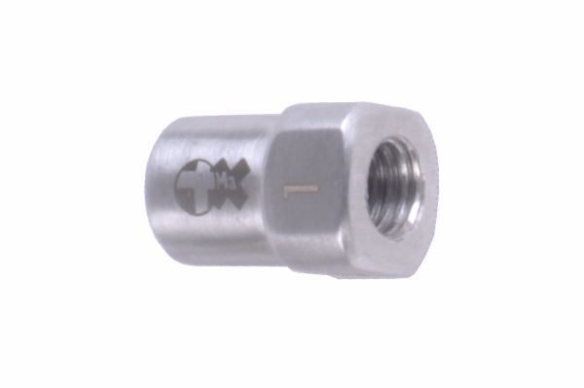
Function
The square nut body has flat sides that accept a standard spanner and engraved calibration lines or numerical markers around the circumference or on the face. Each full turn of the nut advances the rod by the thread pitch (typically 1 mm). The markings allow quarter- or eighth-turn increments to be accurately measured, supporting the 0.25 mm per increment standard distraction protocol.
Advantages
Owner-Performed Distraction Accuracy: Engraved markings enable owners to perform accurate incremental distraction at home by counting marking increments per turn, reducing clinic visit frequency while maintaining the precision required for successful distraction osteogenesis.
Permanent Calibration Markings: Laser-engraved or mechanically stamped markings on surgical stainless steel are permanent and unaffected by repeated autoclaving, blood exposure or cleaning, maintaining legibility throughout the full Ilizarov treatment period.
FAQ
Q: How many turns per day are needed with a standard 1 mm pitch threaded rod?
A: For the standard 1 mm/day protocol divided into four increments, each increment requires a quarter turn (90°) of the marked square nut, easily identifiable using the engraved calibration markings.
Q: Can square nuts with marking replace standard hexagonal nuts in an Ilizarov frame?
A: Yes. Square nuts with marking use the same internal thread as standard Ilizarov nuts and are fully interchangeable, though they require a square-jaw rather than hexagonal spanner.

ORTHOPAEDIC INSTRUMENTS
Ilizarov External Fixator System
Telescopic Rod
Intended Use
Ilizarov telescopic rods are adjustable-length connecting rods used in veterinary circular external fixator constructs to allow controlled linear distraction or compression between rings during limb lengthening, fracture reduction and angular deformity correction in dogs and cats. They replace fixed-length rods where adjustable inter-ring distance is required. | 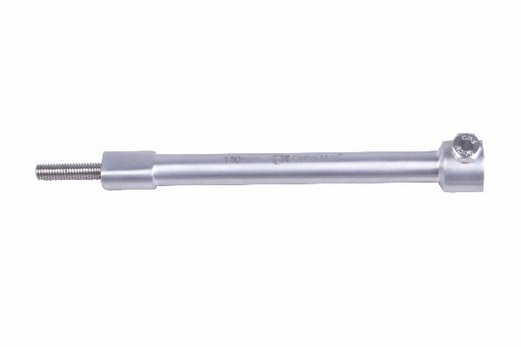
Function
An inner threaded rod slides within an outer tube. The inner rod is advanced or retracted by rotating a nut threaded onto the inner rod against the outer tube face, generating precise linear motion. The telescoping mechanism allows continuous distraction without removing or replacing the rod, and the locking nut secures the rod at the desired length after each adjustment.
Advantages
Continuous Length Adjustment Without Frame Disassembly: The telescoping mechanism allows inter-ring distance to be changed intraoperatively and postoperatively without disconnecting the rod from the rings, enabling distraction protocol adjustments during outpatient consultations without sedation.
Precise Incremental Distraction Control: Fine-pitch threading on the inner rod translates small rotational inputs into precise linear motion, supporting the sub-millimetre daily distraction increments required for successful distraction osteogenesis protocols.
FAQ
Q: What is the maximum distraction range of an Ilizarov telescopic rod?
A: Standard veterinary telescopic rods provide 30–60 mm of linear adjustment, sufficient for most limb lengthening cases in dogs and cats where the planned lengthening rarely exceeds 30–40 mm.
Q: Can telescopic rods be used in compression as well as distraction?
A: Yes. Reversing the adjustment direction applies inter-ring compression, making telescopic rods suitable for fracture compression during the acute fracture fixation phase of Ilizarov treatment.

ORTHOPAEDIC INSTRUMENTS
Ilizarov External Fixator System
Tension Wires - Bayonet Point
Intended Use
Bayonet-point Ilizarov tension wires are Kirschner wires with a three-facet pointed tip used in veterinary Ilizarov circular external fixator assembly. The bayonet tip drills through cortical bone using a power drill, creating a path for the tensioned wire that stabilises bone segments during fracture fixation and distraction osteogenesis in dogs and cats. | 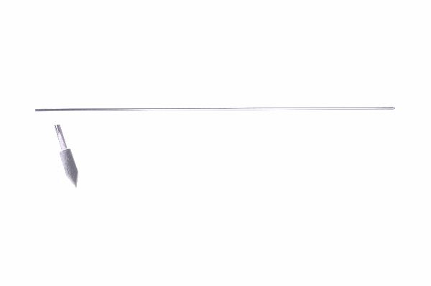
Function
The three-facet bayonet tip geometry creates a cutting action that drills efficiently through compact cortical bone when rotated at power drill speeds. The tip cuts a clean circular channel sized to the wire diameter, minimising thermal bone necrosis at the wire-bone interface. After drilling through both cortices, the wire is tensioned and fixed to the ring using a wire fixation bolt.
Advantages
Efficient Cortical Bone Penetration: The three-facet bayonet tip geometry cuts rather than pushes through cortical bone, reducing drilling time and thermal load at the pin tract — key factors in preventing early pin-tract infection and periosteal necrosis.
Precise Wire Channel Diameter: Bayonet-point wires create a channel closely matching the wire diameter, minimising wire micromotion within the bone channel and reducing pin-tract debris generation that contributes to pin loosening.
FAQ
Q: What drill speed is recommended for Ilizarov bayonet-point wire insertion?
A: Wires should be drilled at speeds above 300 rpm in short bursts of 2–3 seconds with pauses to prevent heat generation, using irrigation to cool the wire at the cortical bone interface.
Q: What diameter bayonet-point wires are available?
A: Veterinary Ilizarov tension wires are available in 1.5 mm and 1.8 mm diameters; 1.5 mm is standard for cats and small dogs, 1.8 mm for medium and large breeds.

ORTHOPAEDIC INSTRUMENTS
Ilizarov External Fixator System
Tension Wires - Trocar Point
Intended Use
Trocar-point Ilizarov tension wires are Kirschner wires with a pyramidal three-facet tip designed for hand or slow-speed power drilling through cortical bone in veterinary Ilizarov circular external fixator assembly. They are used for bone fixation in fracture stabilisation and distraction osteogenesis procedures in dogs and cats. | 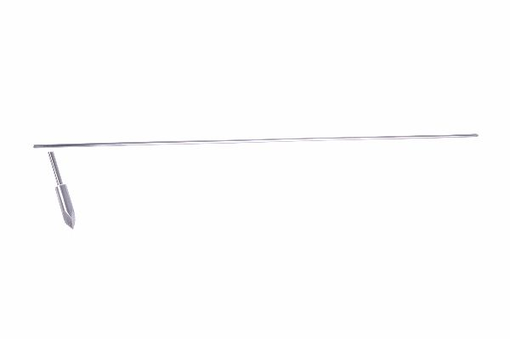
Function
The trocar (pyramidal) tip has three symmetrically ground cutting faces that converge to a central point. This geometry self-centres on the bone surface when pressure is applied and cuts an accurate circular channel on rotation. The trocar point is optimally suited to slow-speed hand or motor drilling, minimising cortical heat generation compared with higher-speed drilling required for diamond-tipped or bayonet wires.
Advantages
Self-Centring Tip for Accurate Entry Point: The pyramidal trocar tip self-positions on the bone cortex at the planned wire entry site, preventing the wire from skidding on the curved bone surface and enabling accurate wire trajectory from the first contact point.
Suitable for Hand Drilling in Field Settings: Trocar-point wires can be inserted by hand chuck in remote or resource-limited veterinary settings where power equipment is unavailable, providing versatility in field and ambulatory equine practice contexts.
FAQ
Q: What is the difference between trocar-point and bayonet-point Ilizarov wires?
A: Trocar points have a three-facet pyramidal tip suited to slow or hand drilling; bayonet points are designed for higher-speed power drilling through hard cortical bone. Both are used for Ilizarov wire fixation.
Q: Can trocar-point wires be tensioned to the same level as bayonet-point wires?
A: Yes. Wire tensioning capacity depends on wire diameter and material, not tip geometry. Both wire types in equivalent diameters achieve identical tension levels after insertion.

ORTHOPAEDIC INSTRUMENTS
Ilizarov External Fixator System
Threaded Rods
Intended Use
Ilizarov threaded rods are the longitudinal connecting elements used to link adjacent rings in veterinary Ilizarov circular external fixator frames. They are used in fracture fixation, limb lengthening, bone transport and angular deformity correction constructs in dogs and cats, determining inter-ring distance and frame stiffness. | 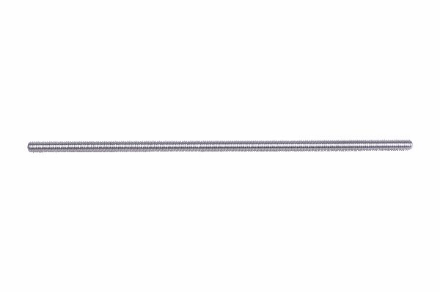
Function
Each rod is fully threaded along its entire length, allowing nuts to be positioned anywhere along the rod to set the precise inter-ring distance. The rod passes through aligned holes in adjacent rings and is secured with nuts on each side of both rings. Advancing or retracting the nuts on one end adjusts the inter-ring gap, generating the controlled distraction or compression used in Ilizarov treatment protocols.
Advantages
Full-Length Threading for Flexible Ring Spacing: Threading along the entire rod length allows rings to be positioned at any inter-ring distance within the rod length, providing maximum flexibility in frame geometry planning for each patient's unique anatomy.
Multi-Rod Frame Redundancy: Using three to four threaded rods evenly spaced around the ring circumference distributes loads between multiple parallel load paths, reducing individual rod stress and providing frame redundancy if one rod loosens during the fixation period.
FAQ
Q: What rod lengths are used in veterinary Ilizarov frames?
A: Standard threaded rod lengths for veterinary use range from 100 mm to 350 mm; they may be cut to length using an orthopaedic rod cutter with the cut end smoothed to remove sharp threads.
Q: What diameter are Ilizarov threaded rods?
A: Standard Ilizarov rods are M6 (6 mm outer diameter) threaded; this dimension is consistent across all Ilizarov ring sizes and ensures compatibility with all standard Ilizarov nuts and ring holes.

ORTHOPAEDIC INSTRUMENTS
Ilizarov External Fixator System
Threaded Socket
Intended Use
Ilizarov threaded sockets are female-threaded connecting components used to join threaded rods end-to-end in veterinary Ilizarov circular external fixator constructs, enabling frame extension beyond single-rod length limits during long-segment limb reconstruction and bone transport procedures in dogs and cats. | 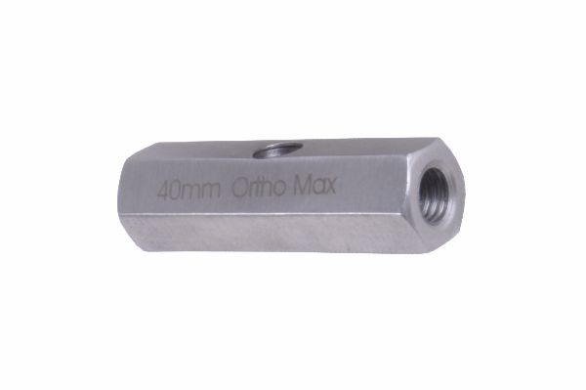
Function
The socket body has internal threading on both ends matching the Ilizarov threaded rod pitch. Each rod end is threaded into one socket end and locked with a nut against the socket face. The connected rods can be aligned coaxially or the socket profile may allow slight angular offset, accommodating minor frame geometry irregularities encountered during intraoperative assembly.
Advantages
Frame Extension Beyond Single Rod Length: End-to-end rod connection via threaded sockets allows the fixator frame to span bone lengths exceeding the available rod lengths in the set, providing versatility for long-segment diaphyseal reconstructions in large-breed dogs.
Rigid Coaxial Rod Union: The threaded socket provides a rigid co-axial connection between rod ends without angular offset (unlike ball-and-socket connectors), maintaining the straight inter-ring geometry required for uniform distraction along the frame axis.
FAQ
Q: Can threaded sockets be used to join rods of different diameters?
A: Standard Ilizarov sockets join rods of the same M6 diameter; adaptor sockets with different thread sizes on each end are available to join rods of different diameters in hybrid constructs.
Q: Do threaded sockets affect frame stiffness?
A: A properly tightened threaded socket junction approaches the stiffness of a continuous rod; the junction should be checked radiographically in the first week to ensure no angular deviation has developed.

ORTHOPAEDIC INSTRUMENTS
Ilizarov External Fixator System
Washers
Intended Use
Ilizarov washers are flat stainless steel discs used in veterinary Ilizarov circular external fixator assembly to distribute connection bolt and nut clamping loads over the ring surface, prevent bolt-head pullthrough and accommodate minor ring surface irregularities during fracture fixation and limb reconstruction in dogs and cats. | 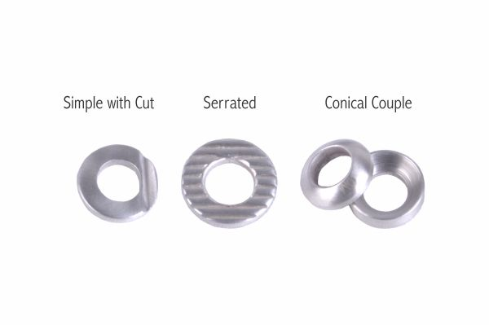
Function
Washers are placed under bolt heads and nuts at ring connection points. The washer face area is substantially larger than the bolt head or nut bearing surface, distributing the clamping force over a wider ring area and reducing point stress concentration at the bolt hole. This prevents ring hole deformation and cracking under high clamping torques, particularly in aluminium alloy rings.
Advantages
Prevents Ring Hole Deformation: Distributing bolt-head and nut bearing loads over the larger washer face area prevents ovalling and deformation of ring bolt holes, particularly critical in lightweight aluminium rings where point loading would otherwise cause permanent deformation at standard tightening torques.
Accommodates Ring Surface Irregularities: The washer face bridges minor surface machining irregularities and ring scratches at connection points, ensuring full bearing contact under the nut or bolt head and preventing asymmetric clamping that could allow component micro-rotation.
FAQ
Q: Are washers required on all Ilizarov connection bolts?
A: Washers are mandatory on aluminium ring systems and recommended on stainless steel rings, particularly at high-load connection points such as threaded rod attachments and distraction mechanism interfaces.
Q: What size washers are used in veterinary Ilizarov systems?
A: Standard Ilizarov washers have an outer diameter of 16–20 mm and a 6.5 mm central hole to accept M6 connection bolts, with a thickness of 1–2 mm.

ORTHOPAEDIC INSTRUMENTS
Ilizarov External Fixator System
Wire Fixation Bolt - Centric or Eccentric Hole
Intended Use
Ilizarov wire fixation bolts are the primary components used to anchor tensioned Kirschner and olive wires to Ilizarov rings in veterinary circular external fixator constructs. Available with centric or eccentric wire holes, they accommodate wire angulation and precise wire positioning relative to the ring hole axis in fracture fixation and distraction osteogenesis cases in dogs and cats. | 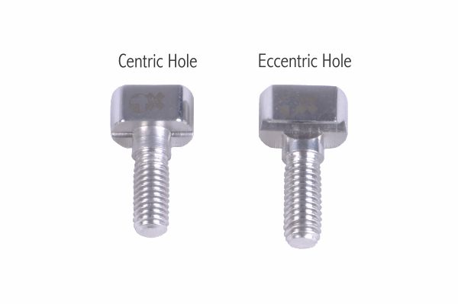
Function
The bolt body threads into the Ilizarov ring hole. The wire passes through the bolt's centric (aligned with the bolt axis) or eccentric (offset from the bolt axis) hole before being tensioned. Tightening the bolt head using the Ilizarov spanner clamps the wire rigidly within the hole. The eccentric hole variant allows the wire to exit the bolt at an offset angle, accommodating divergent wire trajectories in complex ring configurations.
Advantages
Centric and Eccentric Options for Wire Angulation: Eccentric wire fixation bolts allow the tensioned wire to exit at an angle to the ring hole axis, enabling oblique wire trajectories that avoid anatomical structures while maintaining full tension at the ring fixation point.
High-Torque Wire Clamping Without Wire Damage: The bolt clamping mechanism grips the wire shaft over a distributed contact length rather than a single point, preventing wire notching and fatigue stress concentration at the fixation point during cyclically loaded Ilizarov frames.
FAQ
Q: When is an eccentric wire fixation bolt preferred over a centric bolt?
A: Eccentric bolts are used when the required wire trajectory deviates from perpendicular to the ring plane, allowing the wire to be angled to avoid nerves, vessels or growth plates while maintaining secure ring fixation.
Q: How is a wire fixation bolt correctly tightened?
A: Thread the bolt into the ring hole, pass the tensioned wire through the bolt hole, then tighten the bolt hex head using the Ilizarov wrench to the recommended 4–6 Nm while maintaining wire tension with the dynamometric tensioner.

ORTHOPAEDIC INSTRUMENTS
Ilizarov External Fixator System
Wire Tensioner
Intended Use
The Ilizarov wire tensioner is a mechanical instrument used in veterinary Ilizarov circular external fixator assembly to apply tension to Kirschner and olive wires after their passage through bone and ring. Correct wire tension is essential for Ilizarov frame stiffness and effective bone segment control during fracture fixation and distraction osteogenesis in dogs and cats. | 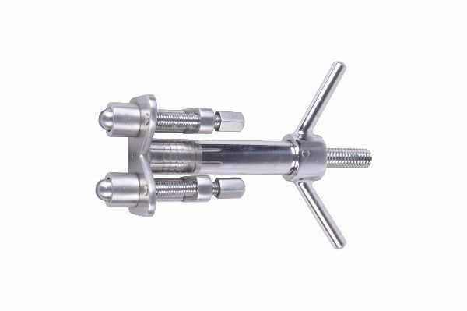
Function
The tensioner clamps onto the free wire end beyond the ring using a lever-activated jaw. Pumping or rotating a ratchet lever draws the wire through the clamp body, applying progressive tension. The surgeon holds the tensioner against the ring face while simultaneously tightening the wire fixation bolt. Once the bolt is tightened, the tensioner clamp is released and the excess wire is cut flush with the bolt.
Advantages
Consistent High Wire Tension Application: The mechanical advantage of the ratchet lever allows the surgeon to achieve and maintain the 90–130 kgf wire tensions required for Ilizarov frame stiffness — tensions impossible to achieve and hold by manual wire pulling alone.
Simultaneous Tensioning and Bolt Tightening: The wire tensioner maintains tension in the wire while the surgeon's other hand tightens the fixation bolt, preventing tension loss between the tensioning and locking steps that would reduce frame stiffness below the required threshold.
FAQ
Q: Is the wire tensioner the same as the dynamometric tensioner?
A: The dynamometric tensioner incorporates a calibrated force gauge for tension measurement; the standard wire tensioner applies tension without a gauge. For precision protocols, the dynamometric tensioner is preferred.
Q: Can the same wire tensioner be used for 1.5 mm and 1.8 mm wires?
A: Many wire tensioners have an adjustable jaw that accommodates both 1.5 mm and 1.8 mm wire diameters; dedicated size-specific tensioners are available where jaw adjustment is not possible.

ORTHOPAEDIC INSTRUMENTS
Ilizarov External Fixator System
Wrenches (Spanner)
Intended Use
Ilizarov wrenches (spanners) are the dedicated tightening tools used to assemble, adjust and dismantle Ilizarov circular external fixator frames in veterinary orthopaedic surgery. They are sized for the standard connection bolt heads, wire fixation bolts, threaded rod nuts and other fasteners used in Ilizarov fracture fixation and limb reconstruction in dogs and cats. | 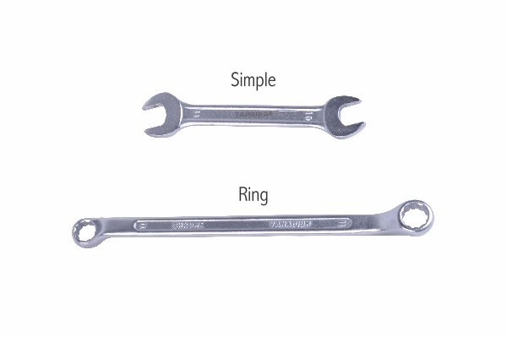
Function
Each wrench is an open-ended or ring spanner sized to the specific nut or bolt head dimensions of the Ilizarov system. The short handle length prevents over-torquing of aluminium ring components. Wrenches are available in T-handle, L-handle and straight open-end configurations; T-handles provide high torque for connection bolts while L-handles allow access to components in confined frame positions.
Advantages
Correct Sizing Prevents Over-Torque Damage: Wrenches sized for the specific Ilizarov fastener dimensions provide the appropriate mechanical advantage to achieve target torque levels without over-torquing, preventing thread stripping and ring hole damage in both stainless and aluminium ring systems.
Multiple Handle Configurations for Frame Access: T-, L- and straight open-end wrench variants allow access to fasteners at all ring positions, including locations where the frame geometry restricts the rotational arc available for conventional spanner use.
FAQ
Q: What sizes are included in a standard Ilizarov wrench set?
A: A standard veterinary Ilizarov wrench set includes 11 mm and 13 mm open-end and ring spanners for connection bolts and wire fixation bolts, plus a dedicated wire fixation bolt wrench for the specific hex profile of the wire bolt head.
Q: Can standard adjustable spanners be used for Ilizarov assembly?
A: Adjustable spanners can be used in emergencies but are not recommended; their jaw slop risks rounding the fastener head profile, particularly on the small hex profiles of wire fixation bolts.

ORTHOPAEDIC INSTRUMENTS
Ilizarov External Fixator System
Wrencho Cube
Intended Use
The Ilizarov wrencho cube is a compact multi-sided wrench tool used in veterinary Ilizarov external fixator assembly and adjustment. Its cube body incorporates multiple wrench faces of different sizes, providing a single compact instrument that replaces several individual spanners for Ilizarov frame assembly during fracture fixation and limb reconstruction in dogs and cats. | 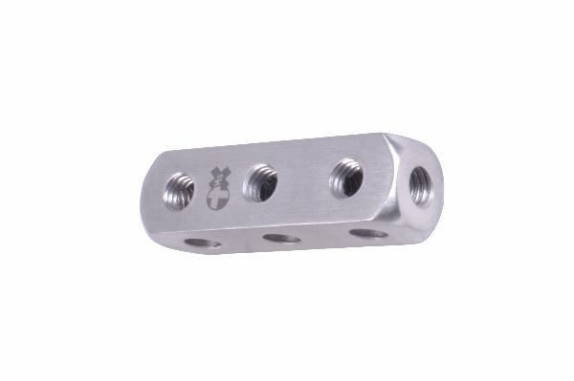
Function
Each of the six faces of the cube incorporates a different socket or open-end wrench profile matched to Ilizarov fastener sizes. The surgeon selects the appropriate face for the fastener at hand and engages it with the nut or bolt head. The compact cube profile allows the tool to be used in the tight spaces within assembled Ilizarov frames where conventional long-handled spanners cannot be manoeuvred.
Advantages
Multi-Size Convenience in One Compact Tool: Six wrench faces on a single cube body replace up to six individual spanners, reducing the instrument count on the surgical tray and simplifying the tool requirement for both intraoperative assembly and postoperative frame adjustment consultations.
Compact Profile for Confined Frame Access: The cube form factor fits between ring levels and through the frame apertures created by tight multi-ring constructs where standard-handle spanners cannot be inserted, enabling complete fastener tightening without partial frame disassembly.
FAQ
Q: What fastener sizes does the Ilizarov wrencho cube cover?
A: The wrencho cube typically covers the 8 mm, 11 mm and 13 mm sizes that correspond to wire fixation bolts, connection bolts and threaded rod nuts — the three most common fastener types in standard Ilizarov frame assembly.
Q: Is the wrencho cube supplied as part of the standard Ilizarov instrument set?
A: The wrencho cube is a supplementary convenience instrument; it is offered as an addition to the standard wrench set and is particularly valued in practices with high Ilizarov case volumes.

